Internship Journal Template (250 to 800 words)

Date
21/5/2025

Internship Company
NTU WANG Yong’s group

Internship Position
One of the main persons in charge of the project.

Supervisor
Wen Xiaolin

Mentor
WANG Yong

Key Objectives
-Before the end of the semester, complete the source code changes and do some simple visualization processing.

Tasks Completed
- Make modifications to the afl++ source code. The specific operation is to write C language code into it and save the output execution content as a log file.
- The specific operation is to write the code and output the appearance of each interesting seed in the queue folder before and after mutation, as well as the mutations they have undergone.
- It also outputs all the mutation strategies that a seed has experienced since its initial mutation. By following the sequence of mutation strategies, we can deduce how the seed has changed step by step.

New Skills Learned
- C language programming ability.
- Ability to operate Linux system.
- And a deep understanding of the entire process of afl++.

Challenges Faced
- The core process of afl++ is not complicated, but there are many code branching points, which will guide the code to different places to execute different contents. Therefore, I spent a lot of time looking for how to classify all these code branches. Finally, I found two places, which are the end points of all branches. Finding these two end points can extract and save all mutation operations in the afl++ process.

How I Overcame Challenges
- I drew a flowchart to help me think, and eventually found the end points of all the code branches.
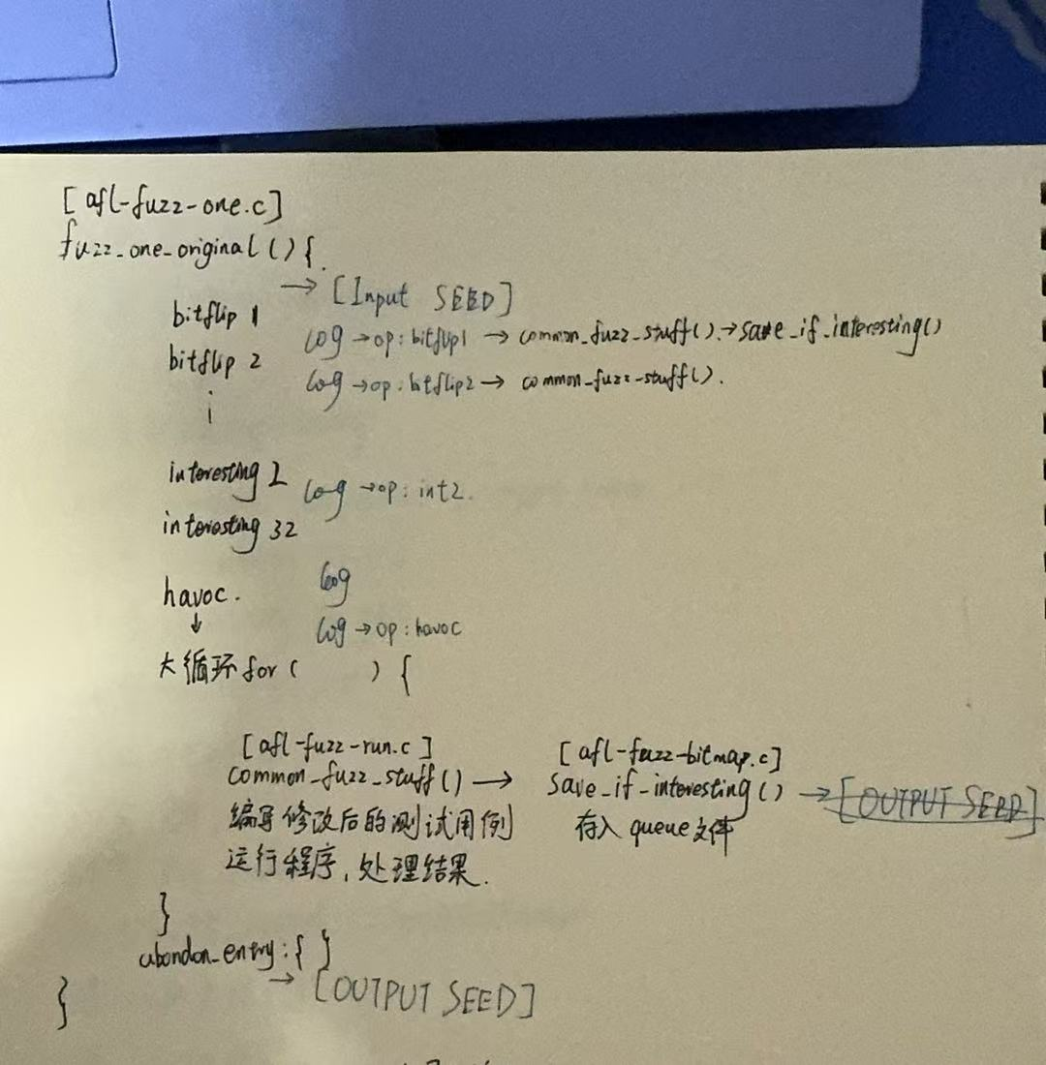

Key Achievements
- Now we have obtained all the information about the seeds before, during and after mutation. The next step is to perform visual analysis.

What I Learned About Myself
- Logical comprehension and patience.

What I Enjoyed Most About the Internship
- When I spent a whole week and used copolit and chatgpt to help me with code analysis and logical judgment, and finally succeeded in understanding the logic of the code, this sense of accomplishment came from the bottom of my heart.

What I Could Have Done Better
- I spent a lot of time in the code analysis process because I couldn't accurately locate the core code of afl++. I think after this practice, I will be able to get started faster when studying afl++ code in the future.

Overall Impression of the Internship
-I found that doing research is really a difficult job, at least for students who have just entered the graduate stage, learning how to do research is an extremely difficult thing. It takes about a year for a person to understand how to conceive a topic, how to write a paper and conduct research from beginning to end.

Future Goals
- Perform visual analysis on the output data.

Additional Notes
None.

This template can be used as a starting point, and you may want to add additional sections or modify the existing ones to better suit your needs. It is important to keep your internship journal up-to-date regularly, so that you can accurately track your progress and reflect on your experiences.

Here are some additional tips for keeping an internship journal:

* Be specific and detailed in your entries.
* Reflect on your experiences both positive and negative.
* Identify areas where you can improve.
* Use your journal to set goals for yourself.
* Share your journal with your supervisor or mentor for feedback.

What are the main objectives of your capstone project?
How does your capstone project relate to your overall academic or professional goals?
What skills and knowledge are you hoping to gain or apply during this project?

Planning Questions:
What is your timeline for the various stages of your capstone project?
What resources do you need to effectively complete your project?
How will you measure the success of your project at different milestones?

Analytical Questions:
What challenges have you encountered in your project so far, and how have you addressed them?
What are the theoretical frameworks or methodologies guiding your project?
How does your project address a gap in the existing literature or market?

Evaluative Questions:
Upon reflection, what aspects of your project do you think are most successful, and why?
How has your understanding of the subject matter evolved since beginning your project?
What would you do differently if you were to start your project over?

